

CENTRIC DMCC

3102 – SABA 1 – JLT

DUBAI 346046 – UAE

W: [www.centric.ae](http://www.centric.ae)

E: [hello@centric.ae](mailto:hello@centric.ae)

T: +971 4 424 0554

Nissan Calculator

Official Website

Functional Specification Document



This page is left blank intentionally for the double sided printing

Contents

1 Document Management & Version Control 7

2 INtroduction 8

2.1 PURPOSE 8

3 Business Requirements 8

3.1 Executive Summary 8

4 SharePoint Solution Packages and Features Naming Convention 9

4.1 SharePoint Solution Packages Naming Convention 9

4.2 SharePoint Features Title and Description Naming Convention 11

5 Branding Solution 13

5.1 Application Setup 13

5.2 Required CSS Media Types 13

5.3 Required Responsive Design Media Queries 13

6 CDN (Content Delivery Network) Libraries 14

7 Language Variations 15

8 Custom Master Page 15

9 Branding 17

9.1 Brand Identification 17

9.2 Browser Specifications 17

9.3 GUI Templates (User Interface) 17

10 Architecture 18

10.1 Topology 18

10.2 Physical Architecture 18

10.3 Logical Architecture 20

11 Pages 22

11.1 Home Page 22

11.2 Master Page 22

11.3 Header 23

11.4 Company Logo 23

11.5 Top Menu 24

11.6 Footer 24

11.7 Links Section 24

12 Page Layouts 26

12.1 Home Page Layout 26

12.2 Content 27

13 Home Page Area and Components 28

13.1 Twitter Feed 28

13.2 Sliding Banner 29

13.3 Administrative Panel for Data Entry 30

13.4 Our Values 30

13.5 Administrative Panel for Data Entry 31

13.6 SLC Events 31

13.7 Administrative Panel for Data Entry 32

13.8 SLC Initiatives and Projects 32

13.9 Administrative Panel for Data Entry 33

13.10 SLC Media Center News 34

13.11 Administrative Panel for Data Entry 35

13.12 SLC Opinion poll section 36

13.13 Administrative Panel for Data Entry 36

13.14 Search 37

13.15 Legislative Supplement 40

13.16 Administrative Panel for Data Entry 42

13.17 Videos and Photos 42

13.18 Administrative Panel for Data Entry 43

13.19 Browser Support Matrix 44

14 Administration & Security 45

14.1 Administration 45

14.2 User permissions and permission levels in SharePoint 2016 47

14.3 Default permission levels 47

14.4 User permissions 50

14.5 List permissions 50

14.6 Site permissions 52

14.7 Personal permissions 54

15 Backup & Restore 55

16 Site Usage Reports 56

16.1 Popularity and Search Reports 56

16.2 Audit Log reports 56

17 Workflows, Groups & Permissions – Official Website 57

18 SiteMap 58

19 Validations, ERROR AND exception handling And Field Attributes 59

19.1 Validation and errors 59

19.2 Exception Handling 59

20 Site and Subsite Structure 60

21 Appendix A 61

21.1 Top Menu Hiearchy 61

21.2 Known Limitations 63

22 Appendix B – Email Content SOME CONTENT WITHOUT WORKFLOW FYI 67

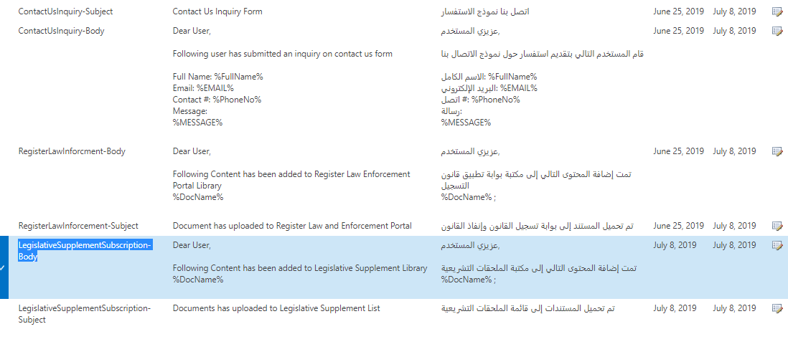 69

Appendix D - EWCM 69

22.1 Add CEWP to Page 69

22.2 Add Content to CEWP 70

22.3 Format Content in CEWP 72

22.4 Configure Common Properties of Web Part 72

22.5 Appearance 73

22.6 Layout 73

22.7 Advanced 74

23 Appendix E - Document Management 77

23.1 SharePoint Library 77

23.2 Types of Libraries 77

23.3 Create Document Library 79

23.4 Add Documents to Library 81

23.5 Delete Document Library 82

23.6 Restore Document Library 83

# Document Management & Version Control

|  |  |
| --- | --- |
| **Document Title:** | Nissan Calculator |
| **Document File Name:** | Nissan Calculator v0.1.docx |
| **Issued By:** | Nawal Harib AlMheiri |
| **Issue Date:** | 20th April 2020 |
| **Reviewed By:** | Saif Ashraf |
| **Status:** | Completed |

|  |  |  |  |
| --- | --- | --- | --- |
| **Date** | **Version** | **Author** | **Remarks** |
| 20th April 2020 | 1.0 | Jahangir Moin |  |

# INtroduction

## PURPOSE

The document contains the functional specifications for the required solution that ‘Centric’ is proposing for ‘Nissan Calculator’. The solution described in the document was devised after a series of requirement gathering meetings between representatives of Centric and Nissan.

Once this document is approved by Nissan, it will serve as the definitive statement of high level scope and requirements for the Nissan Official Website implementation. Any modifications or changes to the requirements after document sign off will be handled via change control procedures.

The high level objectives:

* The availability of seven markets by Nissan MEA catered by EMI calculator. It allows the users to calculate eligibility, model budget by its EMI calculator.
* Basic EMI also includes addition of product add-ons, with every model user is able to add different add-ons.
* There will be maximum of 2 banks in the region. Compare differences between the banks will be provided by the system.
* Compare models allows the user to make comparison between models. It also allow the users to view EMI differences between the grades of different models.

In this regard, Centric has proposed a solution that will be hosted on the Nissan’s platform to facilitate the customers.

The solution will mainly comprise of:

* PIMCORE For CMS Website
* MySQL– Backend Database

# Business Requirements

## Executive Summary

Nissan calculator Official Website is the gateway to calculate the Budget, Eligibility and Model of cars, customer is allowed to add different product add-ons, and the available add-ons are Rims and window tints levels.

This Phase will be a total revamp of Nissan Official Website on PIMCORE technology with the agreed functionalities. The website will be built as new design and extended features.

As all the things are getting digitalize, Nissan wishes to use additional PIMCORE technology to answers corporate needs and enhance existing Official Website capabilities.

The main purpose of this implementation is to give the old website a new face, a new look and feel based PIMCORE technology. The content will be migrated from the old site to the new one with the additional features to fulfill the need of customers.

# Branding Solution

## Application Setup

This section provides the list of the development approach to be taken for the entire project.

|  |  |  |
| --- | --- | --- |
| **Item ID** | **Language** | **Version** |
| **Front-End Semantic** | **HTML** | **1** |
| **Cascading Style Sheet (CSS)** | **CSS** | **1** |
| **Symphony** | **PHP** | **7.4** |
| **JQuery** | **JavaScript** | **1.12.4** |

Table 1: Application Setup

## Required CSS Media Types

This section provides the list of Media Types required for a successful distinct layout implementation for desktops, printing and handheld devices.

|  |  |  |
| --- | --- | --- |
| **Media Type ID** | **Area(s)** | **Description** |
| **Screen** | **Show Header, Content, Footer;** | **Used for computer** |

Table 2: Required CSS Media Types

## Required Responsive Design Media Queries

This section provides the list of Media Queries required for a successful Responsive Design implementation.

|  |  |  |
| --- | --- | --- |
| **Device ID** | **Min. Width** | **Max. Width** |
| **Desktops** |  |  |

Table 3: SLC - Required Responsive Design Media Queries

# CDN (Content Delivery Network) Libraries

This section provides the list of the available content to be deployed over SLC’s CDN (Content Delivery Network).

|  |  |  |
| --- | --- | --- |
| **Domain ID** | **SSL Enabled?** | **Pre-Start Phase Folder** |
| - | **-** | **-** |

Table 4: Branding Solution – CDN - Domain List

|  |  |  |
| --- | --- | --- |
| **Path ID** | **Minified** | **Comments** |
| **assets/css/style.css** | **YES** |  |
| **/assets/css/responsive.css** | **YES** |  |

Table 6: Branding Solution – CDN - Cascading Style Sheet Library

|  |  |  |
| --- | --- | --- |
| **Path ID** | **Minified** | **Comments** |
| **/js/main.js** | **YES** | **JQuery makes things like HTML document traversal and manipulation, event handling, animation, and Ajax much simpler with an easy-to-use API that works across a multitude of browsers** |
| **/js/bootstrap.js** | **Yes** |  |
| **/en-us/js/custom.js** | **Yes** |  |
| **video-js/video.js** | **No** |  |

Table 7: Branding Solution – CDN - JavaScript Library

# Language Variations

This section is to support users in different regions or users who speak different languages and what are the multilingual requirements plan for multilingual site deployment overall plan for the site structure and navigation.

**Users are going to be required to create and delete content only through the source variation site.**

|  |  |  |  |  |  |
| --- | --- | --- | --- | --- | --- |
| **Lang. ID** | **Name** | **Direction** | **Language** | **Locale** | **Is Source** |
| **English** | **En** | **Left To Right (LTR)** | **English (UK)** | **English (UK)** | **Yes** |
| **Arabic** | **Ar** | **Right to Left**  **(RTL)** | **Arabic (UAE)** | **Arabic(UAE)** |  |

D Table 8: Branding Solution - Language Variations

# Custom Master Page

This section define a list of Master Pages and common structure and interface markup elements for the entire Web site, including headers, footers, style definitions, or navigation bars. The master page can be shared by any of the pages in your Web site and removes need to duplicate code for shared elements within the Web site.

|  |  |  |  |
| --- | --- | --- | --- |
| **Master ID** | **File Name** | **Variations** | **CSS Media Types** |
| Default | SLCCorporate.master | English/Arabic | Screen |
| **Content Place Holders** | | | |
| **CPH ID** | **Context** | | |
| AdditionalPageHead | <!DOCTYPE HTML>  <html>  <head>  <title></title>  *<Core CSS References>*  *<Core Scripts References>*  *<Meta References>*  **{AdditionalPageHead}**  </head>  <body>  <header>  *<Header Elements>*  </header>  **{PlaceHolderMain}**    </body>  </html> | | |
| PlaceHolderMain | <!DOCTYPE HTML>  <html>  <head>  <title></title>  *<Core CSS References>*  *<Core Scripts References>*  *<Meta References>*  **{ AdditionalPageHead}**  </head>  <body>  <header>  *<Header Elements>*  </header>  **{PlaceHolderMain}**    </body>  </html> | | |

# Branding

## Brand Identification

User interface of the Nissan Official website will be customized to portray the corporate theme and color of the Nissan ME. A consistent user experience will be ensured by managing the master page and page layouts along with the corporate logo. UI specifications are discussed in detail in their respective sections.

## Browser Specifications

Following browser specifications will apply:

|  |  |
| --- | --- |
| **Ideal resolution** | 1024 x 768 |
| **Target browser** | Internet Explorer 9 or Higher, Mozilla Firefox, Chrome & Safari  For details see Appendix A. |

## GUI Templates (User Interface)

Below are the snapshots of the Nissan Official Website Home and Inner pages. Each section of the Home page will be discussed detail in the forthcoming sections.

# Architecture

## Topology x

Microsoft recommends multiple deployment topologies depending on the degree of availability that is required. Availability is achieved through redundancy, and therefore the higher the required availability, the greater the number of servers that will be required.

For SLC requirements 5 – Server Farm topology is recommended as per the guidelines of Microsoft.

**6 Server Farm**

2 machines will be utilized for SharePoint Web Front-End servers, 2 Server will be for Application server and 2 machines will be utilized for SQL Server databases.

## Physical Architecture







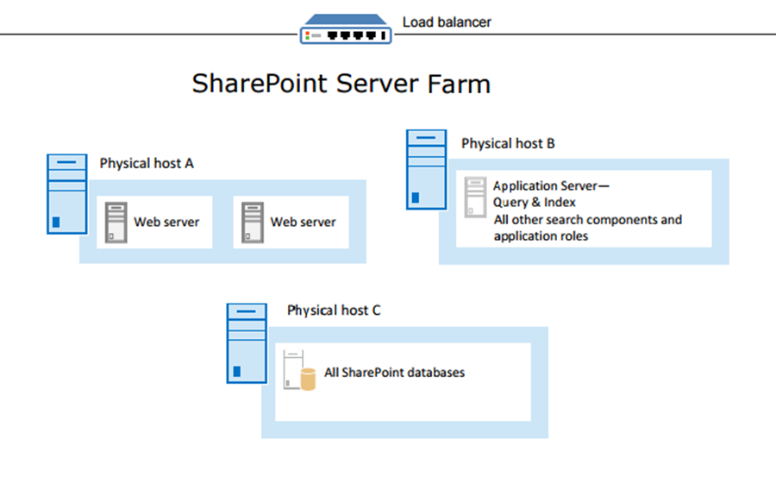

## Logical Architecture x

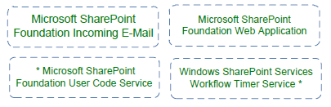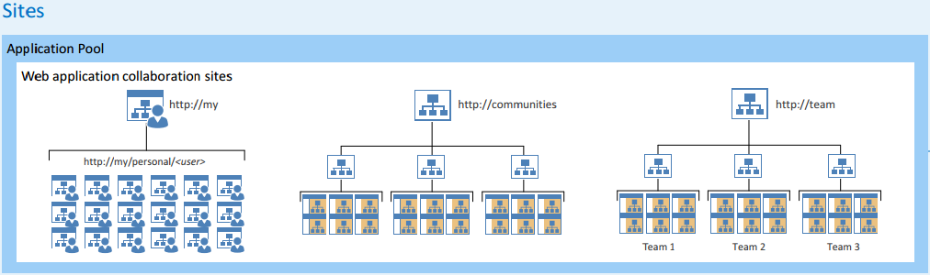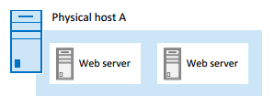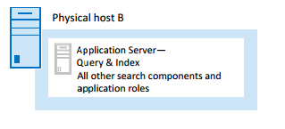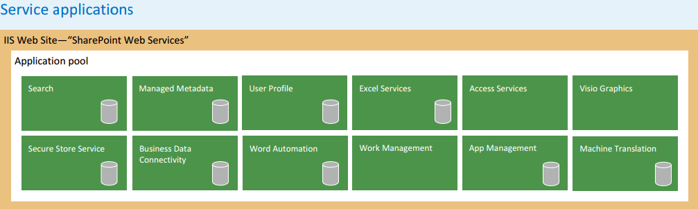

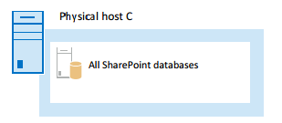



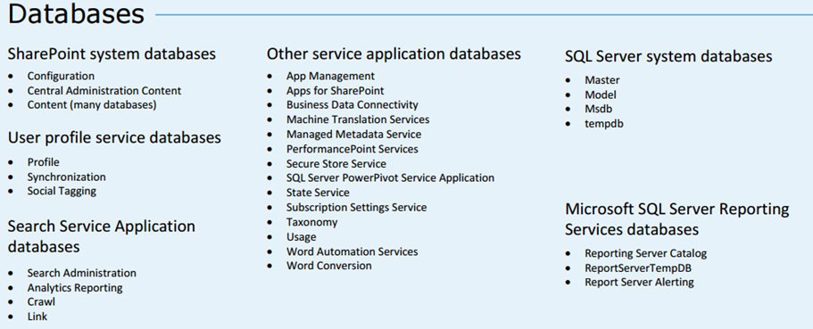

# Pages

## Home Page

Image shown below will be the Home Page of SLC official website:

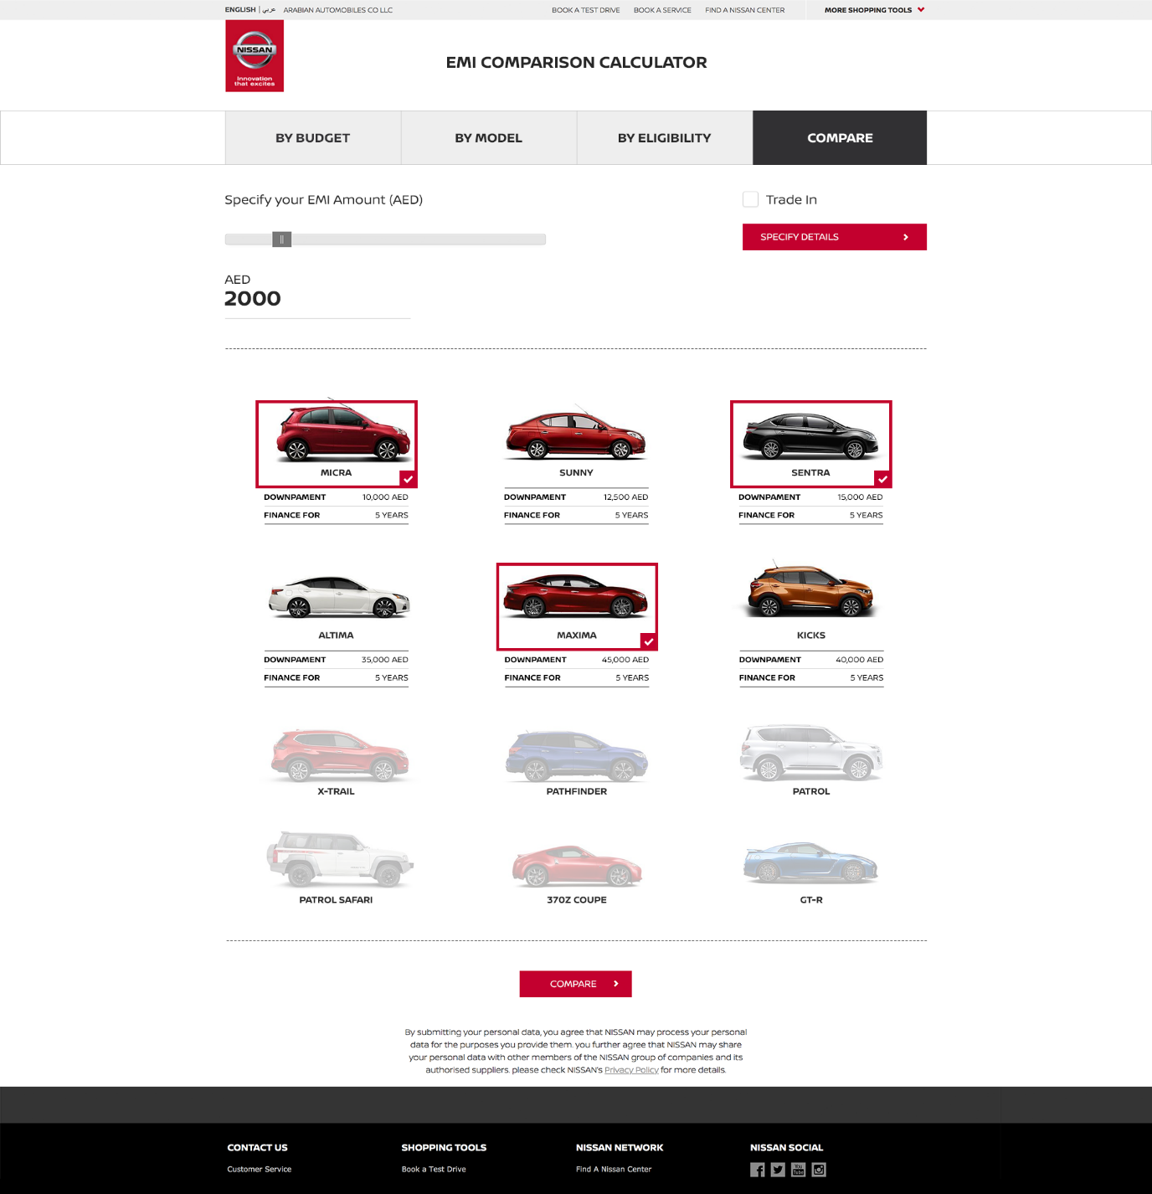

## Header

The header will contain following information.

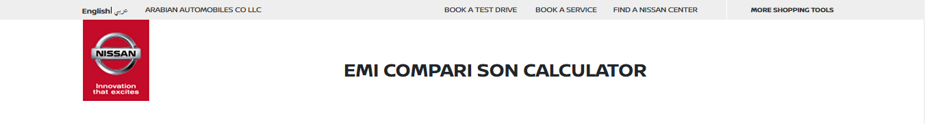

Importantly to note that, header will kept static / fixed throughout the website. The idea is to make header visible all the time to header items.

## Company Logo

On top right of the website, SLC Official Website logo will be placed as shown below. The dimension of logo will be fixed and will be placed in one of the image gallery in SharePoint for future updates if any. Logos will be placed with their respective link.



|  |  |  |  |  |  |
| --- | --- | --- | --- | --- | --- |
| No. | Link Name | Link Location (proposed) | Link Type | Page Type | Link Description |
| 1 | Home | <http://15.185.102.70/>  (can be changed) | Internal | - | Nissan Official Website home page. |

## Top Menu

Top horizontal bar menu will be provided as the universal/primary site navigation method. This navigation style is one of the two most popular kinds of site navigation design patterns. It will be located directly below the website logo on all web pages in the SLC Official Website. The entire site structure will be spelled out in the form of drop-down menus, so user will be able to see everything at one place.



## Footer

The footer will contain following information.

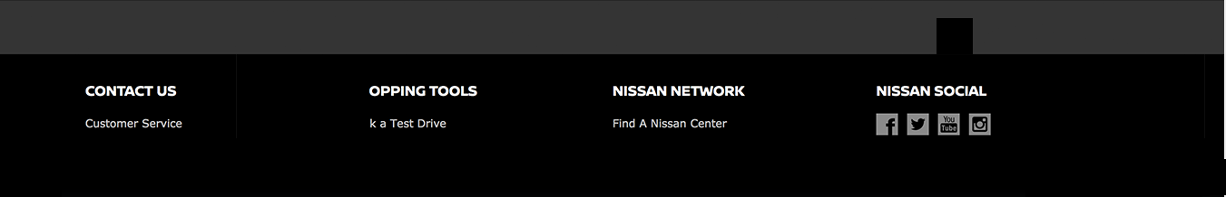

# Page Layouts

## Home Page Layout

Below depicted image is sample of SLC Official Website Home Page. Layout of Home Page will be divided in 4 sections.

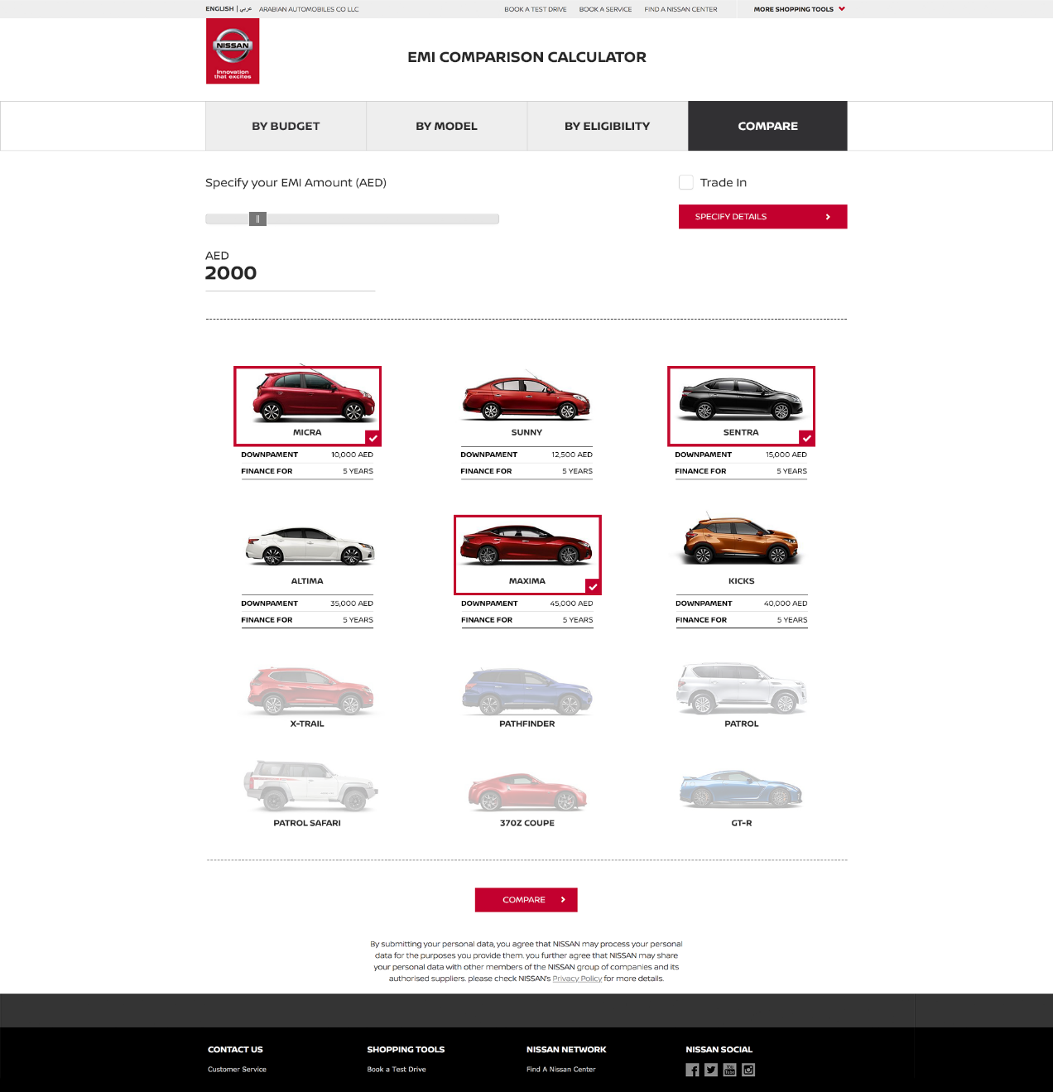

## Content

Apart from Master page components and Home Page Header defined earlier, there will be dedicated space for Home Page components. Regarding dimension of columns, height of all sections will be exactly same as shown. Dimension of every section will be fixed in layout, so placing a component in any section should meet height and width of respective section. For response site, components will be catered accordingly.



**Calculators Section**

**EMI Amount Scale Section**

**Cars Gallery and Description**

**Compare Button**



# Home Page Area and Components

In this section of the document, components placed on home page will be discoursed which will form the complete Home Page as explained earlier.

## CALCULATORS SECTION

First Component of Nissan Home page is calculator section where we select the option by budget, by model, by eligibility and compare.



**How to us?**

For the first three tab, select the respective button will allow you to select the scale type (for example: by budget, by model and by eligibility).

1. For selecting by budget will help you to select the EMI Amount by Slider that is given below:

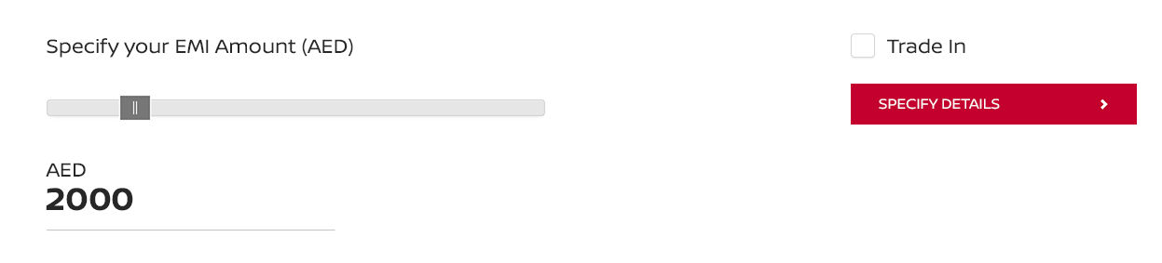

1. By model tab allows you to select the car by model:

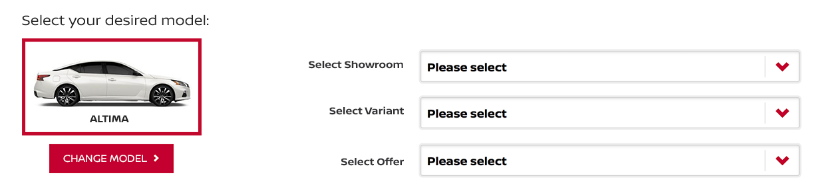

1. By Eligibility tab allows you to select the car by simply entering the price

## EMI AMOUNT Scale Section

In this component web-part of Nissan Home page content will be an EMI amount Scale slider to select the range. Other than that there is an option of “Trade in” and “Specify Details” button that is mentioned in the figure attach below.

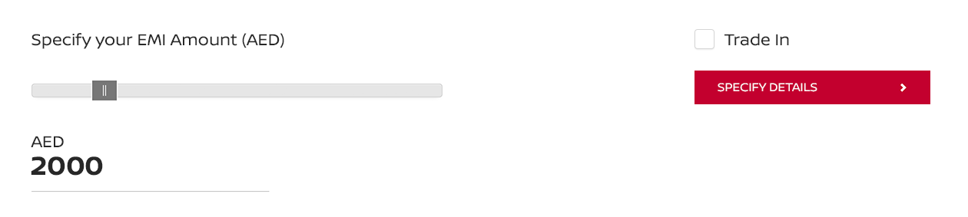

**How to use?**

The Scale will help you select the amount by slider and the “Trade In” check box this will add another option in the car description that is “TRADE IN” with “DOWNPAYMENT” and “FINACE FOR”, the example is given below:

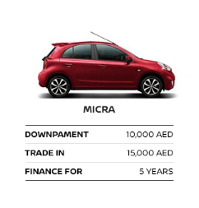

The “Specify Detail” Button will open the new popup, where you can select the Make, Model, Year, Mileage and Approx. Price is given:

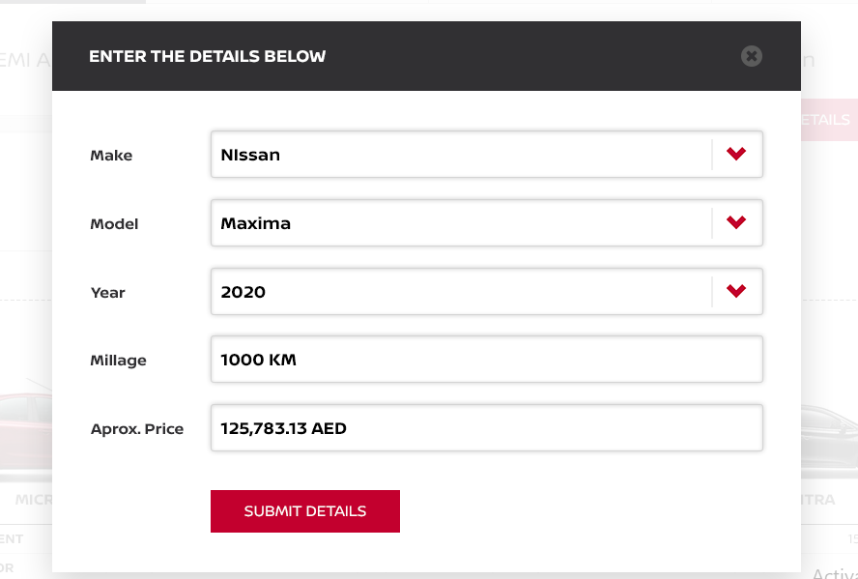

## Car gallery and description section

Below is the car gallery section where the Image of the car and down payment price and finance for year is mentioned

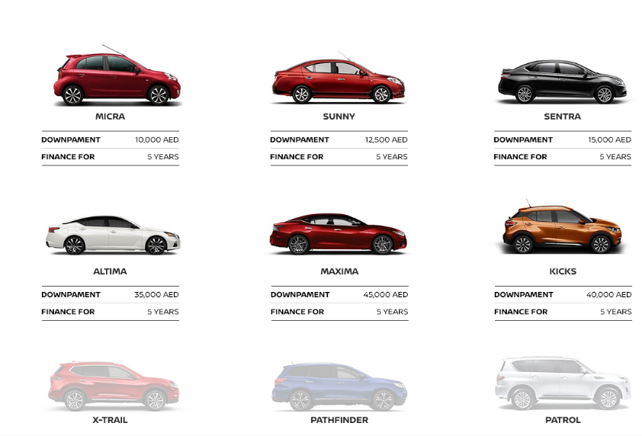

If we select any car let’s suppose “Altima” it will redirect you to page and provide you the variety of features to select showroom, variant, offers.



On selecting the dropdowns it will display the respective showroom price that you have selected, for example:

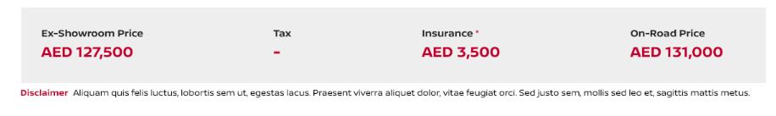

There are many other section where you can select Add-ons (Rims and Window glass tint).

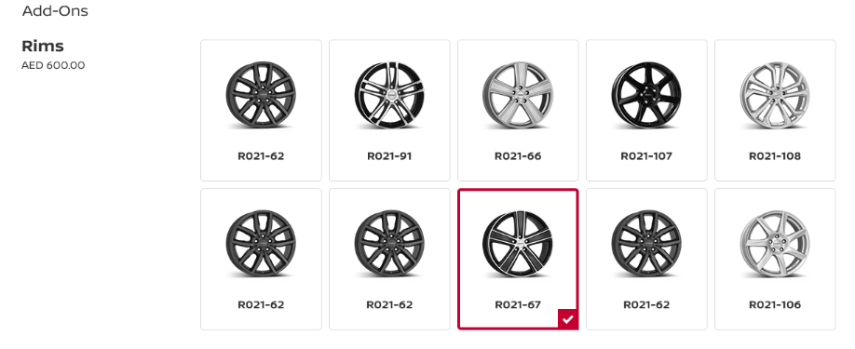

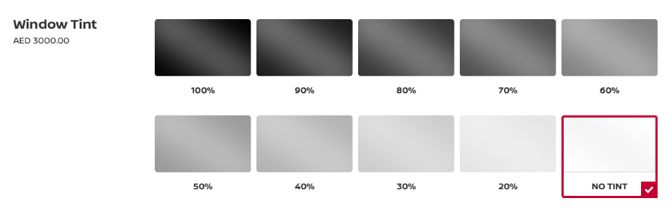

This page also offers you to select an Insurance that you need:

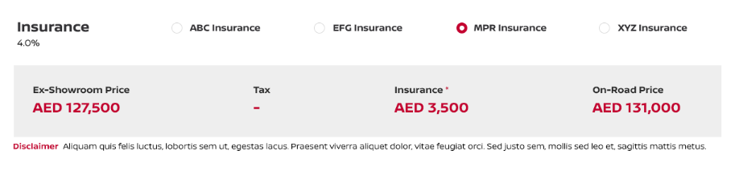

There are many bank offers that are available on the page that allows user to calculate down payments and EMI Tenure (Months).

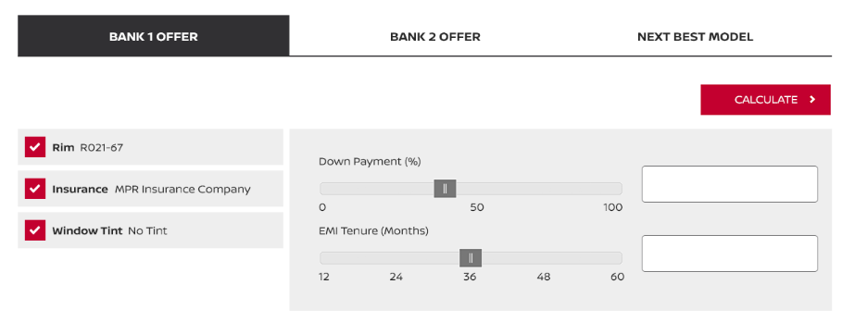

The other option is to calculate your EMI by “Your EMI Calculations”

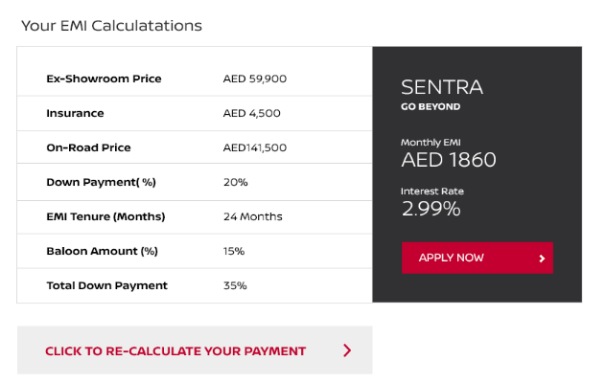

After all the things, page will display the suitable car EMI based upon your salary:

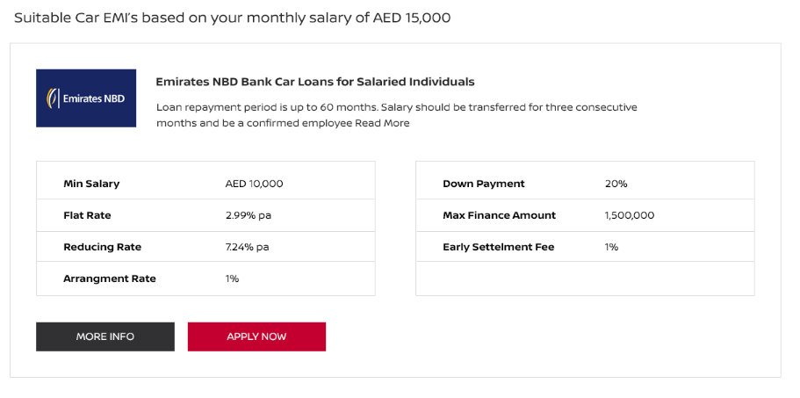

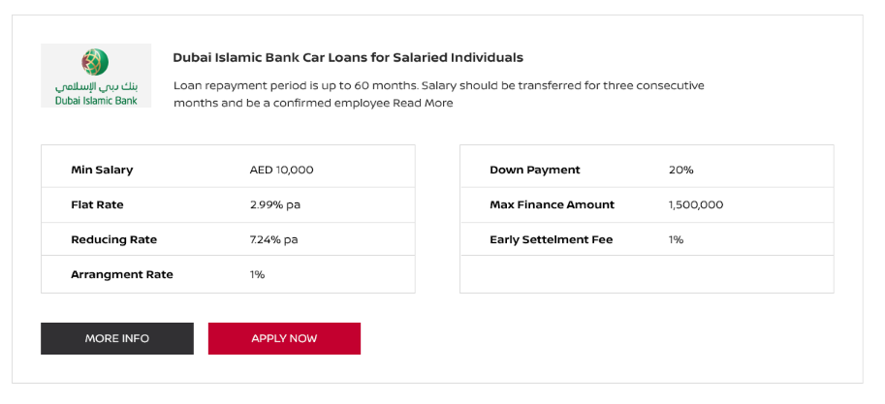

## Compare button

This section contains the “Compare” button redirects the user to the new page where he/she can do comparison by selecting variants check many other details like (Ex showroom price, Insurance, On road price, Down Payment, EMI tenure, Balloon amount%, total down payment, interest rate and finance option ).

On clicking the “Compare” button.



It will redirect the user to comparison page that is attached below:

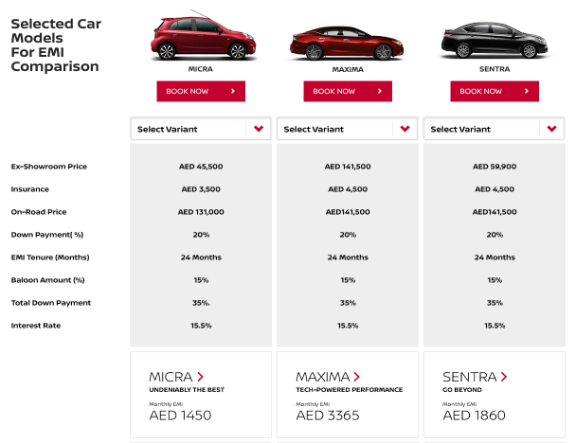

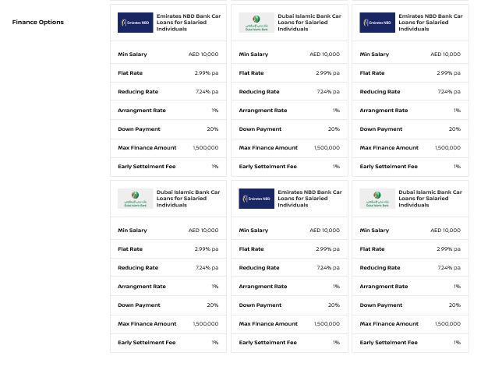

## Browser Support Matrix

SharePoint 2016 supports several commonly used web browsers, such as Internet Explorer browser logo Internet Explorer, Google Chrome browser logo Google Chrome, Mozilla Firefox browser logo Mozilla Firefox, and Apple Safari browser logo Apple Safari. However, certain web browsers could cause some SharePoint 2016 functionality to be downgraded, limited, or available only through alternative steps.

The following table summarizes the support levels of typically used web browsers.

**Support Level of Browsers**

|  |  |  |
| --- | --- | --- |
| Browser | Supported | Not supported |
| Internet Explorer 10 | X |  |
| Internet Explorer 9 | X |  |
| Internet Explorer 8 | X (With limitations) |  |
| Internet Explorer 7 |  | X |
| Internet Explorer 6 |  | X |
| Google Chrome (latest released version) | X |  |
| Mozilla Firefox (latest released version) | X |  |
| Apple Safari (latest released version) | X |  |

# Administration & Security

## Administration

Administration in pimcore consist of following topics:

* [Backup of Pimcore](https://pimcore.com/docs/5.x/Development_Documentation/Administration_of_Pimcore/Backups.html)
* [Command line Interface of Pimcore](https://pimcore.com/docs/5.x/Development_Documentation/Administration_of_Pimcore/Commandline_Interface.html)
* [Users and Roles](https://pimcore.com/docs/5.x/Development_Documentation/Administration_of_Pimcore/Users_and_Roles.html)

## Commandline interface

Pimcore offers certain tasks a commandline command. Use the following command to get a full list of available tasks:



## User permissions

In Pimcore there are two levels of user permissions. Firstly, the permissions on system components and secondly permissions on data elements (assets, objects and documents). Permissions can be granted to roles or individual users. The following paragraphs describe how and where permissions can be set and how they will or will not affect each other.

It is not mandatory to use roles, permissions can be granted to users directly. However, it is advised to use roles if there is a larger user group to manage. In the user/role settings tab it can be decided which permissions are granted to that user or role. An individual user has a few more general settings than the role.

**Systems Permission:**

* Admin - if checked, all permissions on all system components are granted to that user
* Show welcome screen on startup
* Show close warning
* Roles - Select all roles incorporated by the user
* Perspectives - Which [perspectives](https://pimcore.com/docs/5.x/Development_Documentation/Tools_and_Features/Perspectives.html) are available for this user

The following list outlines what the different system permissions (available for users and roles) mean:

* **Assets**: assets tree is visible
* **Backup**: backup functionality is visible
* **Bounce Mail Inbox**: Bounce Mail Inbox visible
* **Classes**: Object classes editor visible (user can create and modify object classes)
* **Clear Cache**: defines if a user may clear Pimcore cache (internal cache and response cache if configured)
* **Clear Temporary Files**: defines if user may delete temporary system files (e.g thumbnails)
* **Dashboards**: User can create Dashboards
* **Documents**: documents tree is visible
* **Document Types**: User can create and modify predefined document types
* **Emails**: User sees E-Mail history
* **Glossary**: Glossary entries visible
* **HTTP Errors**: HTTP Errors are visible
* **Notes & Events**: Notes & Events are visible
* **Objects**: objects tree is visible
* **Plugins**: specifies if a user is allowed to download install and manage extension
* **Predefined Properties**: User can create and modify predefined properties
* **QR-Codes**: User can create and modify QR codes
* **Recycle Bin**: User has access to recycle bin
* **Redirects**: User can create and modify redirects
* **Reports**: User has access to reports module
* **Seemode**: Seemode available/not available for user
* **SEO Document Editor**: User has access to SEO document editor
* **System Settings**: User has access to system settings
* **Tag & Snippet Management**: User can create and modify entries in tag & snippet management
* **Targeting**: User has access to targeting module
* **Thumbnails** User can create and modify thumbnail configurations
* **Website Translations**: defines whether a user may view and edit website translations
* **Users**: defines whether a user may manage other users' settings and system permissions
* **Website Settings**: User can create and modify website settings

## ELEMENT PERMISSION WORKSPACE

A user needs to be granted access to one or more workspaces. The user cannot access any resources outside of his workspace(s).

However, there are a few general rules on element permissions which need to be regarded:

* if a user does not have the right to list an element, all other permissions are obsolete
* if a user does not have the list permission on an element, all permissions on this element's children are obsolete.

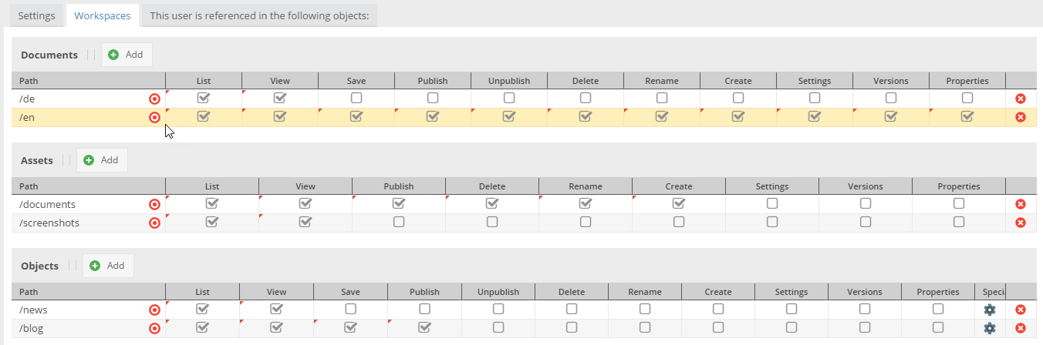

The user permissions on element basis are summed up as follows:

* **list**: element can be listed in tree
* **view**: element can be opened
* **save**: element can be saved (save button visible)
* **publish**: element can be published (publish button visible)
* **unpublish**: element can be unpublished (unpublish button visible); does not exist for assets
* **create**: new child elements can be created (does not exist for assets)
* **delete**: element can be deleted
* **rename**: name of the element can be changed
* **settings**: element's settings can be managed i.e. the settings tab is visible; the settings permission also the path and thereby the right to move the element in tree
* **versions**: versions tab available
* **properties**: properties tab available and can be managed

## Adding Personal permissions

Choose a custom unique name and add it to the “user_permission_definitions” table in database. select the permission in the users/roles tabs:

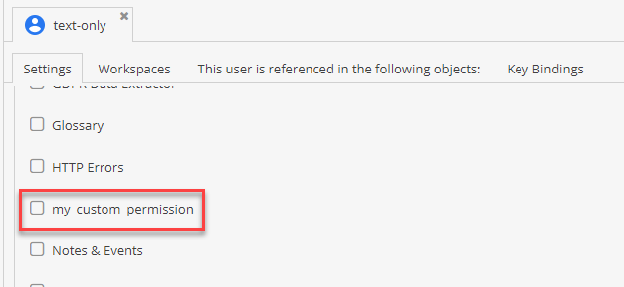

# Backup & Restore

## Backup of pimcore

The recommendation of the usage of standard tools depending on infrastructure for creating a backup of your Pimcore instance.

## Poor man backup using linux tools

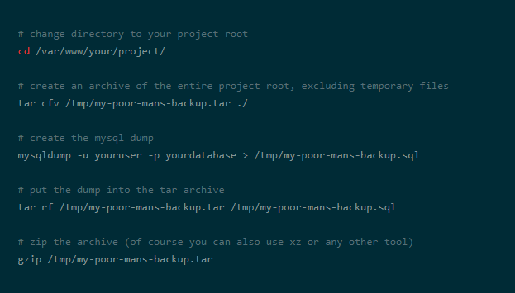

# SiteMap

Pimcore includes the [presta/sitemap-bundle](https://github.com/prestaconcept/PrestaSitemapBundle) which adds a simple, yet powerful API to generate XML sitemaps.

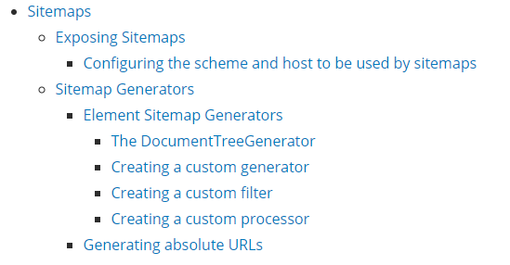

**Element Sitemap generator**

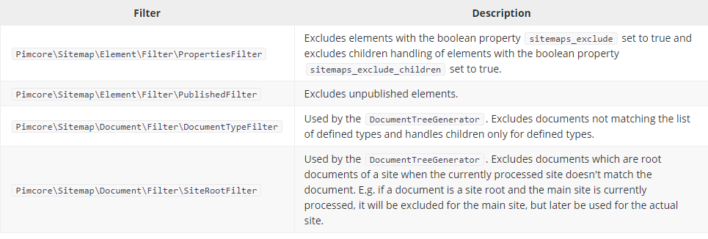

# ERROR AND exception handling And Field Attributes

## Exception Handling

We can check the errors through SSH , SFTP and on the debugging mode of Pimcore.

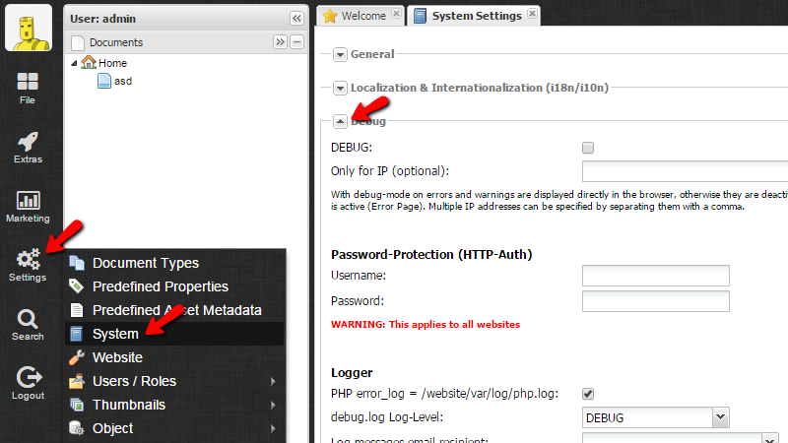

# Site and Subsite Structure

The Structure of site has been provided in the following screenshots.

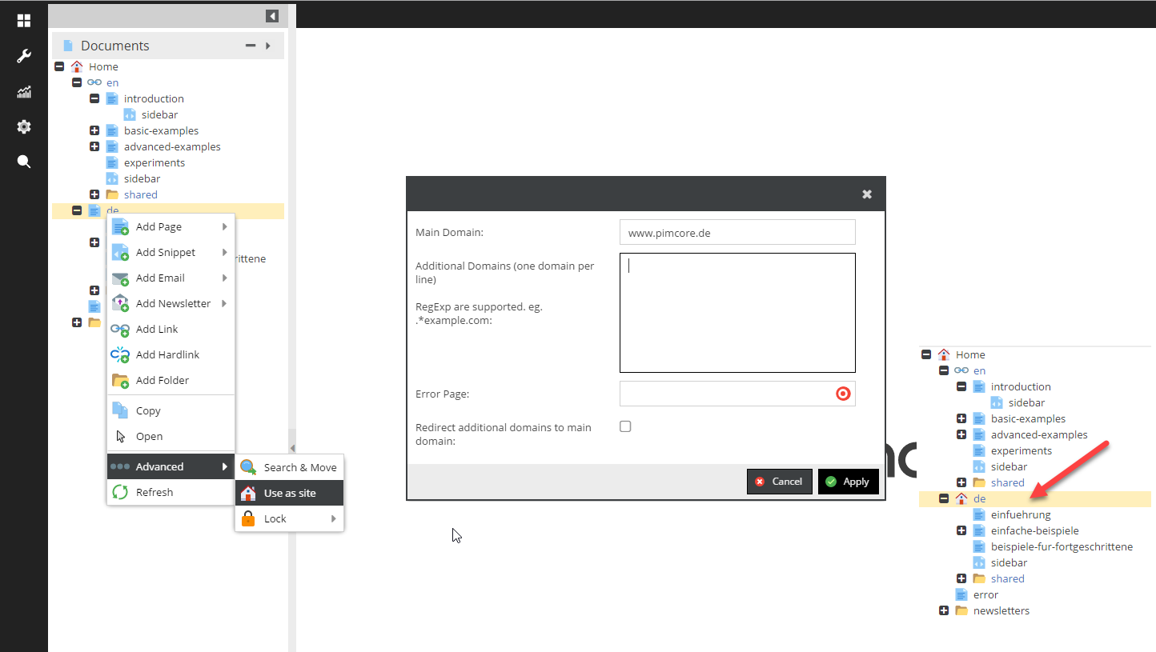

# Appendix A

## Top Menu Hiearchy

|  |  |  |  |
| --- | --- | --- | --- |
| **Top** | **Child Link** | **Link Type** | **Link Description** |
| Region | None | internal | Redirects user to regions |
| Bank | Car | internal | Redirects user to finance calculator page |
| Insurance | Car | internal | Redirects user to finance calculator page |
| Distributor | Car | internal | Redirects user to finance calculator page |
| Car | offers | internal | Redirects user to finance calculator page |
| Car | Model | internal | Redirects user to EMI Calculator page |
| Car | Showroom | internal | Redirects user to finance calculator page |
| Model | Add-ons | internal | Redirects user to finance calculator page |
| Model | Variant | internal | Redirects user to finance calculator page |
| Add-ons | Rims | internal | Redirects user to finance calculator page |
| Add-ons | Widnow Tint | external | Redirects user to finance calculator page |

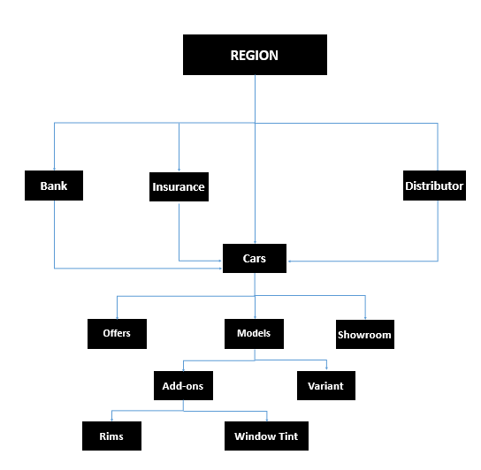

# Appendix D - EWCM

The Content Editor Web Part (CEWP) is intended for adding content to a page which may include formatted text, tables, hyperlinks, images, and Google maps etc.

## Format Content in CEWP

You can format the content, typed directly into the CEWP, using the editing tools available from the ribbon. To access these editing tools, from the Page tab, in the ribbon, click Edit. The ribbon includes six groups of formatting options which are described in the table that follows.

|  |  |  |
| --- | --- | --- |
| **No.** | **Group** | **Description** |
| 1 | Font | Use these tools to format selected text in the Web Part. You can modify the font type, size, and color, make text bold or italicized, highlight selected text, and strike through it, among other things. |
| 2 | Paragraph | Use these tools to format selected paragraphs in the Web Part. You can modify the alignment of the text, indent it, create a numbered or bulleted list, and change the order in which information in the paragraph is displayed. |
| 3 | Styles | Apply a preformatted style to selected text. To preview a style, select the text you want to format, and then drag your cursor over the style option you want to preview. |
| 4 | Spelling | Check the spelling of text on the page. This option is available only when the spell checking feature is installed. |
| 5 | Layout | Create or remove columns, headers, or footers on the page.   NOTE    This option affects the entire page, not just the content in the Content Editor Web Part. |
| 6 | Markup | Use these tools to insert specific HTML elements into the content. You can select a preformatted style from the Markup Styles drop-down menu, or create your own by accessing the HTML Editor from the HTML drop-down menu. You can also mark text as being in a specific language. |

## Configure Common Properties of Web Part

Web parts share a common set of properties that control their appearance, layout, and advanced characteristics. You can change CEWP properties in the tool pane.

Note: For a specific Web Part, a Web Part developer may have chosen not to display one or more of these common properties or may have chosen to create and display additional properties that are not listed below in the Appearance, Layout, and Advanced sections of the tool pane. To see the advanced section in the tool pane, you must have appropriate permission. Some permission and property settings may disable or hide Web Part properties.

## Appearance

|  |  |  |
| --- | --- | --- |
| **No.** | **Property** | **Description** |
| 1 | Title | Specifies the title of the Web Part that appears in the Web Part title bar. |
| 2 | Height | Specifies the height of the Web Part. |
| 3 | Width | Specifies the width of the Web Part. |
| 4 | Chrome State | Specifies whether the entire Web Part appears on the page when a user opens the page. By default, the chrome state is set to Normal and the entire Web Part appears. Only the title bar appears when the state is set to Minimized. |
| 5 | Chrome Type | Specifies whether the title bar and border of the Web Part frame are displayed. |

## 

## Layout

|  |  |  |
| --- | --- | --- |
| **No.** | **Property** | **Description** |
| 1 | Hidden | Specifies whether the Web Part is visible when a user opens the page. If the check box is selected, the Web Part is visible only when you are designing the page and has the suffix (Hidden) appended to the title. You can hide a Web Part if you want to use it to provide data to another Web Part through a Web Part connection, but you do not want to display the Web Part. |
| 2 | Direction | Specifies the direction of the text in the Web Part content. For example, Arabic is a right-to-left language; English is a left-to-right language. This setting may not be available for all types of Web Parts. |
| 3 | Zone | Specifies the zone on the page where the Web Part is located. Zones on the page are not listed in the list box when you do not have permission to modify the zone. |
| 4 | Zone Index | Specifies the position of the Web Part in a zone when the zone contains more than one Web Part. To specify the order, type a positive integer in the text box. If the Web Parts in the zone are ordered from top to bottom, a value of 1 means that the Web Part appears at the top of the zone. If the Web Parts in the zone are ordered from left to right, a value of 1 means that the Web Part appears on the left of the zone.  For example, when you add a Web Part to an empty zone that is ordered from top to bottom, the Zone Index is 0. When you add a second Web Part to the bottom of the zone, its Zone Index is 1. To move the second Web Part to the top of the zone, type 0, and then type 1 for the first Web Part.  Each Web Part in the zone must have a unique Zone Index value. Therefore, changing the Zone Index value for the current Web Part can also change the Zone Index value for other Web Parts in the zone. |

## Advanced

|  |  |  |
| --- | --- | --- |
| **No.** | **Property** | **Description** |
| 1 | Allow Minimize | Specifies whether the Web Part can be minimized. |
| 2 | Allow Close | Specifies whether the Web Part can be removed from the page. |
| 3 | Allow Hide | Specifies whether the Web Part can be hidden. |
| 4 | Allow Zone Change | Specifies whether the Web Part can be moved to a different zone. |
| 5 | Allow Connections | Specifies whether the Web Part can participate in connections with other Web Parts. |
| 6 | Allow Editing in Personal View | Specifies whether the Web Part properties can be modified in a personal view. |
| 7 | Export Mode | Specifies the level of data that is permitted to be exported for this Web Part. Depending on your configuration, this setting may not be available. |
| 8 | Title URL | Specifies the URL of a file containing additional information about the Web Part. The file is displayed in a separate browser window when you click the Web Part title. |
| 9 | Description | Specifies the ScreenTip that appears when you rest the mouse pointer on the Web Part title or Web Part icon. The value of this property is used when you search for Web Parts by using the Search command on the Find Web Parts menu of the tool pane. |
| 10 | Help URL | Specifies the location of a file containing Help information about the Web Part. The Help information is displayed in a separate browser window when you click the Help command on the Web Part menu. |
| 11 | Help Mode | Specifies how a browser will display Help content for a Web Part.  Select one of the following:   * Modal – Opens a separate browser window, if the browser has this capability. A user must close the window before returning to the Web page. * Modeless – Opens a separate browser window, if the browser has this capability. A user does not have to close the window before returning to the Web page. This is the default value. * Navigate – Opens the Web page in the current browser window. |
| 12 | Catalog Icon Image URL | Specifies the location of a file containing an image to be used as the Web Part icon in the Web Part List. The image size must be 16 by 16 pixels. |
| 13 | Title Icon Image URL | Specifies the location of a file containing an image to be used in the Web Part title bar. The image size must be 16 by 16 pixels. |
| 14 | Import Error Message | Specifies a message that appears if there is a problem importing the Web Part. |

# Appendix E - Document Management

## Document types

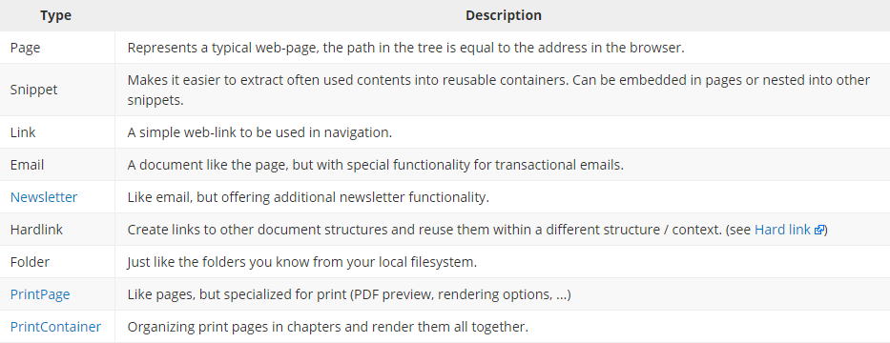

## pre defined document type

Pimcore provides the ability to define pre configurations for documents, which makes it easier for editors to work with many different controller/action and templates. By using this feature the editors don't have to have any knowledge of which controller/action/template should be used in a specific document because they can choose out of a predefined set of configurations with a friendly name.

**Example:**

To define document-type go to Settings > Document-Types.

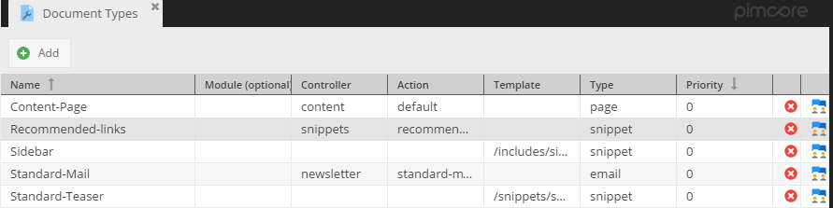

Let's suppose that you've created controller, action and template for a books listing.

Reference to the action: **\BookController::listAction**

Reference to the template: **website/views/scripts/book/list.php**

To add a new document-type which renders the book listing template, you have to click on the Add button first and then fill out the newly created configuration row accordingly.

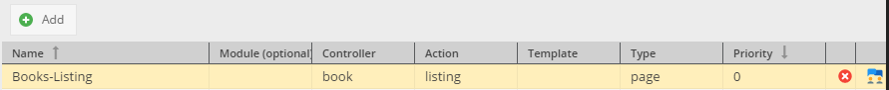

The type can be either a page, snippet, email, newsletter, printcontainer or printpage.  
After you have defined a type you can access it in the context menu or in the document settings:

##### **Document Settings Preview:**

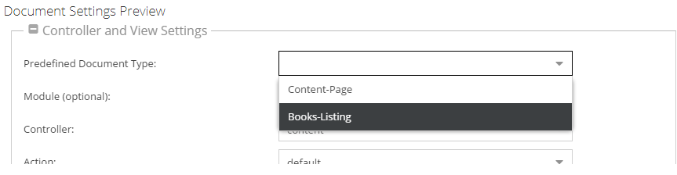

##### **Context Menu Preview:**

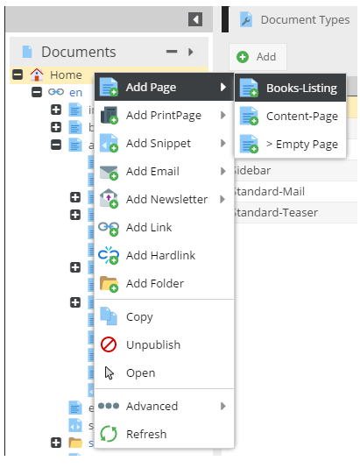

## Directory structure

|  |  |
| --- | --- |
| Directory | Description |
|  |  |
| /app/ | The application configuration, templates and translations |
| /bin/ | Executable files(e.g. bin/console) |
| /doc/ | Core files of Pimcore, do not change anything here. |
| /src/ | The Project’s PHP code. (Services, Controller etc.) |
| /var/ | Private generated files - not accessible via the web (cache, logs, etc.). |
| /vendor/ | All third party libraries are there. It’s a default location for package installed by composer/packagist. |
| /web/ | This is the **document root** (public folder) for your project - point your vhost to this directory! |

**The /web/ Directory:**

The web root directory is the home of all public and static files like images, style sheets and JavaScript files. It is also the place where each front controller (the file that handles all requests to your application) lives, such as the [production controller](https://github.com/pimcore/skeleton/blob/master/web/app.php).

**The /app/ Directory:**

The AppKernel class is the main entry point of the Symfony application configuration and as such, it is stored in the directory.